**Project group - 3**

**Vamshi reddy musku , srinandh reddy gaddam , amrutha valli parangi , srinivasa rao medisetti.**

**Appendix C. User Manual**

# Description:

The aim of the application is to facilitate students to understand in a better way about the nature of wandering in the grid of forest by providing a graphical simulation. Student of each grade will make a specific configuration on the size and shape details of the forest . Senior students can be able to assign to different strategies so that. They can wander and compare the results.

**System Requirements, Dependancies**

We need to have python application to execute the program successfully

* System Requirements:

○ Python 3 (above 3.7 is recommended) ● Library Dependencies:

○ numpy

○ matplotlib

○ tkinter

* Python File Dependencies:

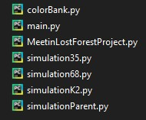

# Launch the project

Click on the command prompt or terminal it will navigate to the folder in which the dependency phython files are collected.

1. Launch Program command as below.

C:\Users\Software Engineering\Project>python main.py

1. A window prompt will pop up.

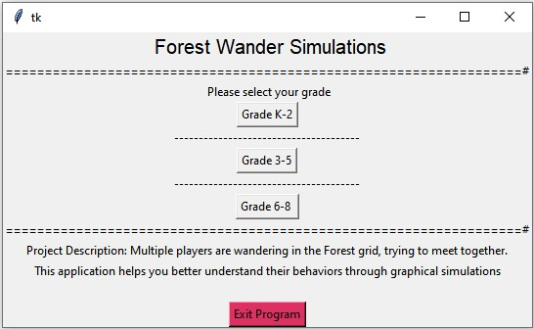

1. An appropriate grade level has to be selected by the students . By clicking on the grade button it will navigate the students to a new page

**Simulations :**

# Grade K -2

1. For grade K - 2 students, the grid has to be in square. The students are to enter a length in between 2 -50 . Then pressing the step 1 button , a forest grid will be intialized .

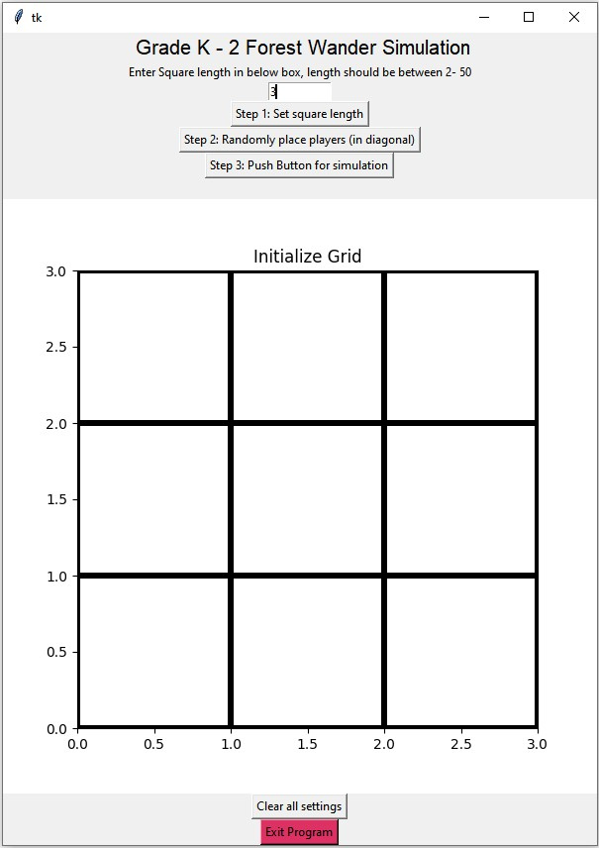

1. Selecting the step 2 button will arrange the players in different positions randomly. For k-2 , it always plays 2 players in diagonal .

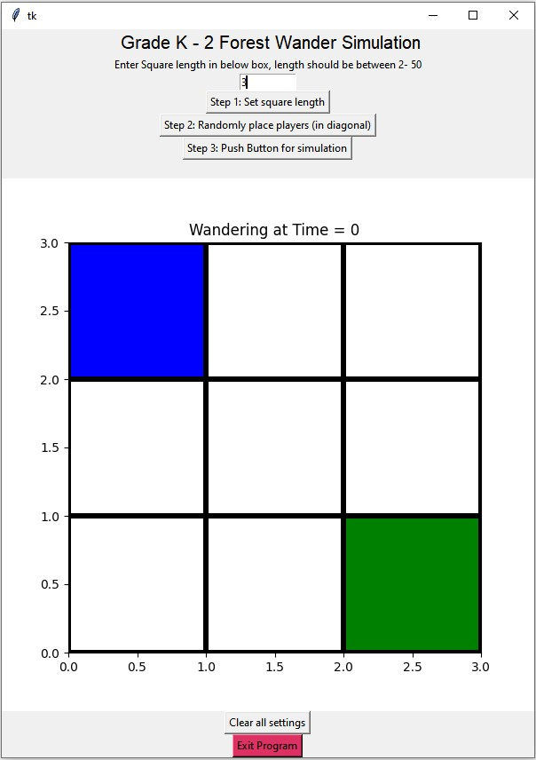

1. Step 3 button initiates the simulation, red cell denotes the meeting.

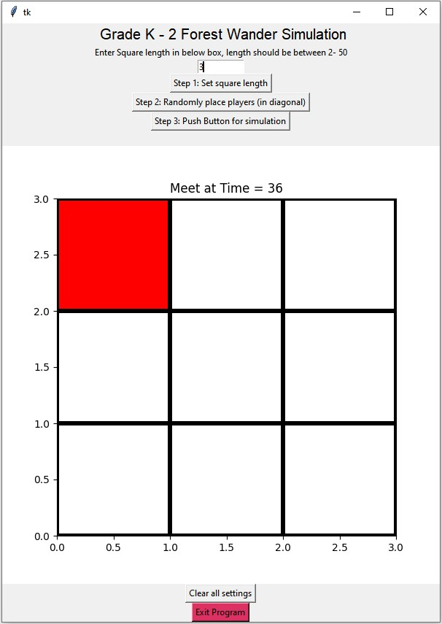

1. To clear out all the plots’ , click clear all settings or click Exit Program’ to exit.

# Grade 3 - 5

The illustrations presented below will determine on the difference between the grades . The similar setups in the previous sections will be ignored.

1. towards senior grade students , more flexibilities are granted . They can now have rectangular shaped grid with multiple plays (between 2 to 4)

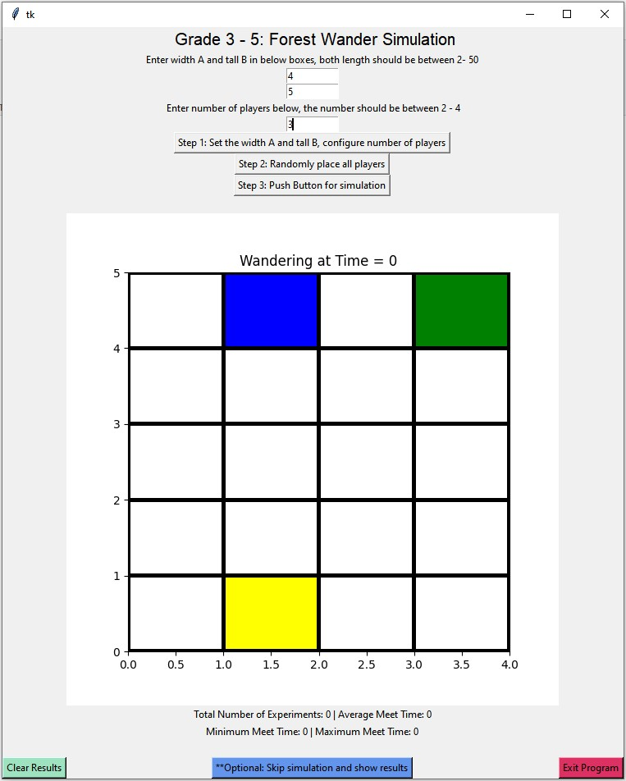

1. some of the simulations will take longer time in animations. The blue button on the bottom will indicate skip the animation process and can directly land onto the results. Notice that summary statistics are updated below the animation, with the information of number of runs, minimum/maximum/average run time.

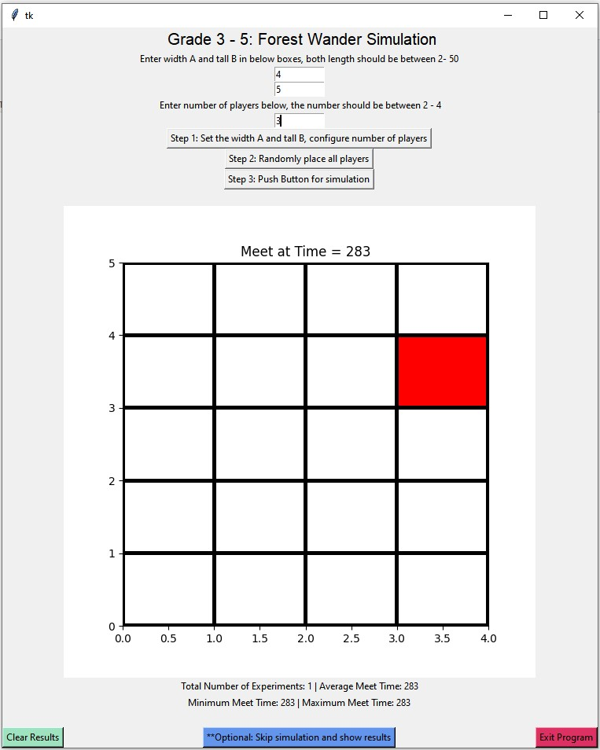

1. This green button indicates the ‘Clear Results’, that will clear out the summary statistics once it is clicked .

# Grade 6 - 8

For Grade 6-8 students, the additional functionality is added , they are different wander strategies. In previous simulations, the default wandering strategy is random walk.

Then students can be able to select 1 for ‘all wander but one’. This strategy stabilizes one of its players, and lets the other players keep wandering to meet at the stabilized position.

Or the students can choose 2 - Determined Move. In this plan , all the players will make determined moves by sticking to one direction till they are forced to change it, which means reaching the barriers and so on .